**Assignment solution**

1. How to deal with insufficient baselines in project.
2. Track resource availability
3. Manage workload allocation to track hour-by-hour availability
4. View project schedules to monitor task progress
5. Monitor resource productivity on your project dashboards.

2.

1. **Use requirement management software to set a change control process:** Lay out an idiot proof change control system. Embrace a prerequisites the executives programming to direct the course of necessity extraction and the board. It ought not be only a progression of changes passed from one channel and one individual on to another yet an appropriately reported, straightforward and identifiable cycle. Programming will introduce an unmistakable image of where every necessity stands, what undertakings and obligations are set apart against it and how it has developed.
2. **Convey the impact of specific changes:** Partners may not entirely fathom the roundabout effect of the progressions regarding individual hours and different expenses. Be forthright on how explicit changes might prompt unforeseen confusions and postponements in the venture. Cause partners to comprehend which changes lead to critical far reaching influences.
3. **Be flexible and adaptable within reason:**Be versatile, responsive, and reasonable. Best expect that necessities are subject to future turns of events. With this technique, you spread out a positive relationship with outside accomplices and augmentation your potential outcomes getting their support later
4. **Get clear SLAs:**Administration level arrangements ought to be painstakingly phrased and on schedule. Allow arrangements plainly to state terms of the cooperation, the workplaces and impairs before you start.

**3.**

**Management reserve should not be used in the in the following** ;

To offset or minimize existing cost variances

To offset accumulated overruns or underruns

For a contingency budget that can be used for new work

It’s not eliminated from the contract price during negotiations

It’s not included as part of the performance measurement baseline

4. Creating a gnatt chart would monitor each employ working hours and tasks carried out would help keep track of all member in the project implementation

Sample of such Gnatt is shown below;

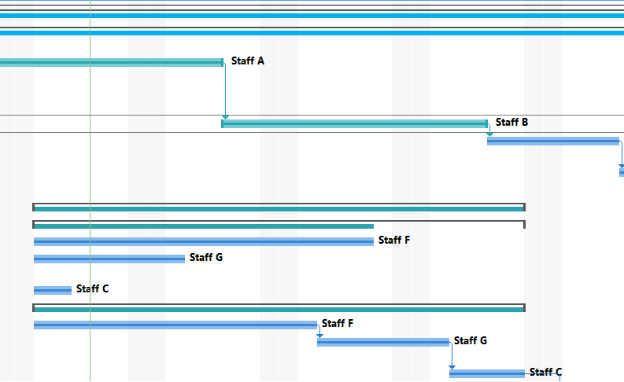

1. You should address OCOG and inform him the risk of insufficient funds would set the project at risk of failing to deliver the expected scope, completing on time, and staying within the financial budget. This issues should be reported to International Olympic committee (IOC) if no action taken by OCOG.
2. Change management, which has seen many PMs and organizations across the world upskilling and adopting it across their projects’ processes. Hold a discussion with staffs operational level to device the way forward.
3. For any change in project the changes should be passed through a series of steps to assess its validity.

This steps include;

1. Get as much information as possible
2. Assess whether the request is within the scope
3. Determine what’s required to make the change request happen
4. Decide whether to approve or reject the change request
5. You should not react right away. There’s nothing much can be said at the moment without checking boss or HR first.

Some of the answers that can be given to the employee are without offending him Its not to me”. Don’t look angry, irritated or resistant. Discuss the matter with seniors in our case ICO

1. **While managing troublesome partners, you want to remove feeling from the situation. Try not to think about things literally. Be self-assured even with protest. Remaining proficient and placing your undertaking objectives and targets regardless of anything else will assist you with seeing all the more plainly.**
2. **Honesty, responsibility, respect and fairness** are the values that drive ethical conduct for the project management profession. PMI’s Code of Ethics and Professional Conduct applies those values to the real-life practice of project management, where the best outcome is the most ethical one. It would indicate high ethical value if such information was shared.
3. **First is identification of the reasons is the main key. This will enable you to explain in details the course of project delays as to why the project is behind schedule. Possible options to deal with delays is working overtime which is very often in order to get on track. Working overtime will require more expenses and this leads to over budget.**